Sub layer of the Data Link Layer

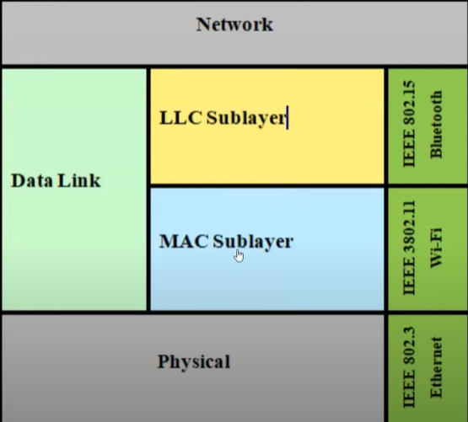

1. Logical Link control (LLC) or Data Link Control (DLC) sublayer
   1. Handles communication between upper and lower layers.
   2. Takes the network protocol data and adds control information to help deliver the packet to destination. (Flow control)
2. MAC sublayer
   1. Interacting with the physical layer. Physical layer has the NIC cards.
   2. Constitutes the lower sublayer of the data link layer.
   3. Implemented by hardware, typically in the computer NIC.
   4. Two primary responsibilities:
      1. Data encapsulation
         1. Frame assembly before transmission and frame disassembly upon receiving of a frame.
         2. MAC layer adds a header and trailer to the network layer PDU.
         3. Provides three primary functions:
            1. Framing
            2. Physical addressing or MAC addressing
            3. Error control
         4. Responsible for the placement of frames on the media and the removal of frames from the media.
         5. Communicates directly with the physical layer.
      2. Media access control

